INDEX
NAME OF THE CONTENT PAGE NO.
1. INTRODUCTION 1-2
1.1 Aim of the Project
1.2 Objectives of the Project
1.3 Scope of the Project
2. EXISTING SYSTEM 3-4
2.1 Overview
2.2 Risk Analytics in the Existing System
2.3 Backtesting in the Existing System
2.4 Portfolio Optimization in the Existing System
2.5 Transaction Cost Analysis (TCA)
2.6 Reporting
3. PROPOSED SYSTEM 5-6
3.1 Overview
3.2 Risk Management
3.3 Backtesting
3.4 Portfolio Optimization
3.5 Transaction Cost Analysis (TCA)
3.6 Reporting
4. SYSTEM ANALYSIS 7-9
4.1 Functional Requirements
4.2 Non-Functional Requirements
4.3 Constraints
4.4 Assumptions
NAME OF THE CONTENT PAGE NO.
5. SYSTEM ARCHITECTURE 10-19
5.1 Introduction
5.2 Objectives
5.3 Architecture Overview
5.4 Workflow
5.5 Technology Stack
5.6 Key Features
5.7 Advantages
6. MODULE DESCRIPTION 18-20
6.1 Risk Analytics Module
6.2 Backtesting Module
6.3 Portfolio Optimization Module
6.4 Transaction Cost Analysis (TCA) Module
6.5 Reporting and Dashboard Module
7. OUTPUT AND RESULTS 21-29
7.1 Risk Analytics Output
7.2 Backtesting Results
7.3 Portfolio Optimization Results
7.4 Transaction Cost Analysis Results
7.5 Overall Performance Summary

NAME OF THE CONTENT PAGE NO.
8. TESTING AND VALIDATION 30-31
8.1 Unit Testing
8.2 Integration Testing
8.3 System Testing
8.4 Performance Testing
8.5 User Acceptance Testing (UAT)
8.6 Validation Approach
9. DEPLOYMENT AND MAINTENANCE 32-33
9.1 Deployment Approach
9.2 Security Measures
9.3 Monitoring and Maintenance
9.4 Backup and Recovery
9.5 Maintenance Plan
10. FUTURE ENHANCEMENTS 34-35
10.1 Real-Time Risk Monitoring
10.2 Additional Asset Classes
10.3 Artificial Intelligence and Machine Learning
10.4 Advanced Dashboards
10.5 Collaboration Features
10.6 System Integration
10.7 Cloud-Native Architecture
10.8 Compliance Enhancements

NAME OF THE CONTENT PAGE NO.
11. APPENDICES 36-38
11.1 Risk Calculation Formulas
11.2 Stress Testing Scenarios
11.3 Sample Report Layouts
11.4 Glossary of Terms
11.5 References and Standards
1. INTRODUCTION
1. Introduction
Portfolio management in today’s financial markets is increasingly complex due to factors such as high volatility, rapid market changes, large transaction volumes, and stringent regulatory requirements. Investment teams require powerful analytical tools to understand risks, evaluate strategies, optimize asset allocations, and monitor trading costs. Without such tools, portfolios are exposed to unexpected losses, inefficient trading, and potential non-compliance with regulations.
This project addresses these challenges by developing an integrated system that combines Risk Analytics, Backtesting, Portfolio Optimization, Transaction Cost Analysis (TCA), and Reporting into a single unified platform. Each module serves a specific purpose: the Risk Analytics module evaluates potential portfolio losses, the Backtesting module assesses historical strategy performance, the Portfolio Optimization module recommends asset allocations under defined constraints, the TCA module identifies actual trading costs and efficiency improvements, and the Reporting module consolidates results into clear, actionable reports. Together, these modules provide investment teams with the necessary tools to make well-informed, efficient, and secure portfolio management decisions.
1.1 Aim of the Project
The primary aim of this project is to design and develop a comprehensive Risk, Backtesting, Portfolio Optimization, and Transaction Cost Analysis (TCA) System that assists investment teams in managing portfolios effectively. In volatile and fast-moving markets, portfolios face risks such as sudden price movements, sector downturns, and unforeseen trading costs. The system is designed to equip financial professionals with the tools to measure and manage these risks, test trading strategies using historical data, optimize asset allocations, evaluate trading costs, and generate reliable reports. The ultimate goal is to ensure safer, more informed, and data-driven decision-making in portfolio management.
1.2 Objectives of the Project
The main objective of this project is to provide a unified platform that integrates multiple portfolio analysis functions. Key objectives include risk measurement, strategy testing, portfolio optimization, transaction cost analysis, and comprehensive reporting. The system will calculate metrics such as Value at Risk (VaR) and Expected Shortfall (ES) to estimate potential losses. It will allow users to test investment strategies, such as momentum and mean reversion, on historical data to understand their performance. Portfolio optimization functionality will recommend the best mix of assets within constraints like turnover limits, sector caps, and risk budgets. The TCA module will measure hidden costs, including slippage, commissions, and market impact, to enhance trading efficiency. Finally, the system will generate daily and weekly reports providing both high-level summaries and detailed insights into portfolio
performance, risk, and costs. By meeting these objectives, the system will act as a decision-support tool, improving accuracy, transparency, and reliability in portfolio management processes.
1.3 Scope of the Project
The scope of the project encompasses all key stages of portfolio risk and performance analysis. The system will include modules for Risk Analytics, Backtesting, Portfolio Optimization, TCA, and Reporting. The Risk Analytics module will measure potential losses under both normal and stressed market conditions. Backtesting will simulate historical investment strategies while incorporating realistic trading costs. Portfolio Optimization will recommend allocations that balance risk and return under specified constraints. The TCA module will analyze execution costs and suggest improvements. Reporting will provide daily and weekly summaries of portfolio health, performance, and risks.
The system is not intended to execute live trades, provide real-time market predictions beyond backtesting, or handle tax and accounting functions. Its primary focus is to serve as a reliable and transparent analytical platform that supports investment decision-making and portfolio management.

2. EXISTING SYSTEM
2.1 Existing System
In the current environment, most investment teams rely on a mixture of manual processes, spreadsheets, and standalone tools to handle risk analysis, backtesting, optimization, and transaction cost evaluation. While these tools provide some insights, they are fragmented, time-consuming, and not always reliable. The lack of integration and automation creates inefficiencies, increases the chances of errors, and makes it difficult to respond quickly to market changes.
2.2 Risk Analytics in the Existing System
- Risk is usually calculated using separate spreadsheets or basic third-party software.
- Value at Risk (VaR) and Expected Shortfall (ES) calculations are often inconsistent and may not run daily.
- Factor exposures (such as sector or currency risk) are checked manually, which results in incomplete risk coverage.
- Stress testing is irregular and not integrated into daily processes.
- Breach alerts are not automated; managers often identify issues only after they have occurred.
2.3 Backtesting in the Existing System
- Backtesting is carried out through custom scripts developed by analysts or quants.
- These scripts are not standardized, so results vary across users.
- Trading costs like commissions, slippage, or market impact are usually ignored, making the results unrealistic.
- Results are not reproducible because input data, configurations, and code versions are not stored.
2.4 Portfolio Optimization in the Existing System
- Optimization is often attempted using simple spreadsheet models.
- Constraints such as turnover limits, sector restrictions, or risk budgets are not fully supported.
- Trade recommendations are calculated manually, leading to higher chances of mistakes.
- Expected return and risk forecasts are not systematically presented.

2.5 Transaction Cost Analysis (TCA) in the Existing System
- TCA is usually handled manually or outsourced to brokers.
- Analysis focuses only on average costs, without detailed breakdowns by venue or algorithm.
- There is no system for weekly or trend-based reporting, making it difficult to track patterns in costs.
2.6 Reporting in the Existing System
- Reports are generated from different sources, leading to inconsistencies.
- They are usually limited to static Excel or PDF files with minimal detail.
- Reports are not audit-ready since they do not store data snapshots or code versions.
- Compliance and audit teams find it difficult to verify results.

3. PROPOSED SYSTEM
3.1 Proposed System
The proposed Risk, Backtesting, Portfolio Optimization, and Transaction Cost Analysis (RPAS) System is a fully integrated platform that automates all essential functions of portfolio management. It is designed to replace fragmented processes with a single, consistent, and audit-ready system.
3.2 Risk Management in the Proposed System
- Automated calculation of VaR and ES at both 95% and 99% confidence levels.
- Detailed factor exposure reports showing risk distribution across sectors, industries, and asset classes.
- Predefined stress scenarios such as interest rate shocks, volatility spikes, and sector crashes built into the system.
- Automated breach alerts that notify risk managers when limits are exceeded.
3.3 Backtesting in the Proposed System
- Built-in support for common strategies like momentum and mean reversion, with flexibility for custom strategies.
- Incorporation of real-world trading costs (commissions, slippage, and market impact) for realistic results.
- Application of risk constraints such as volatility caps and maximum drawdowns.
- Complete reproducibility by saving configurations, random seeds, and code versions along with results.
3.4 Portfolio Optimization in the Proposed System
- Optimization engine that generates recommended portfolio weights under multiple constraints (turnover limits, sector caps, risk budgets).
- Automatic calculation of recommended trades to transition from current holdings to optimized portfolios.
- Reporting of expected risk-return outcomes to help managers evaluate trade-offs before execution.
- Audit-ready storage of optimization runs for future reference.
3.5 Transaction Cost Analysis (TCA) in the Proposed System
- Automated measurement of slippage, commissions, and market impact.
- Venue and execution algorithm performance analysis to identify cost-saving opportunities.
- Profit and Loss (P&L) attribution into alpha, beta, costs, and timing factors.
- Weekly TCA reports with trend analysis and recommendations for improvement.
3.6 Reporting in the Proposed System
- Daily risk and performance reports covering VaR, ES, exposures, Sharpe ratio, drawdowns, and TCA highlights.
- Weekly TCA reports with execution quality analysis.
- Reports available in PDF, Excel, and interactive dashboard formats.
- All reports are audit-ready and linked to specific data snapshots, configurations, and code versions.

.

4. SYSTEM ANALYSIS
4.1 System Analysis
System analysis is the process of understanding what the system must do, how it should behave, and under what conditions it will operate. This section outlines the functional requirements (what the system should perform), non-functional requirements (how the system should perform), as well as the constraints and assumptions that apply to the RPAS project. It ensures that both technical and business needs are clearly defined before implementation.
4.2 Functional Requirements
Functional requirements define the operations and feature’s that the system must provide to its users. For the RPAS system, these requirements cover data handling, risk analytics, backtesting, portfolio optimization, transaction cost analysis, and reporting.
4.2.1 Data Ingestion and Validation
The system must load daily market data, including prices, factors, interest rates, and volatility, along with portfolio holdings, executed trades, and positions from internal databases. Data validation checks will ensure completeness (no missing values) and correctness (no invalid entries). Snapshots of input data will be stored to maintain a full audit trail.
4.2.2 Risk Analytics
The system will calculate key risk measures, including Value at Risk (VaR) and Expected Shortfall (ES) at 95% and 99% confidence levels. Factor exposure reports will show contributions from sectors, industries, and asset classes. The system will support predefined stress testing scenarios and automatically generate alerts if risk limits are breached. Daily risk results will be stored for historical reference.
4.2.3 Backtesting
Users will be able to test investment strategies such as momentum and mean reversion. Trading costs, including commissions, slippage, and market impact, will be included in simulations. Risk limits such as maximum drawdowns and volatility caps will be applied. Performance reports covering returns, Sharpe ratio, volatility, and drawdowns will be generated after each backtest. All configurations, inputs, and results will be saved to enable reproducibility.
4.2.4 Portfolio Optimization
The system will suggest optimal portfolio weights based on constraints such as turnover limits, sector caps, and risk budgets. It will recommend the set of trades required to move from current holdings to optimized holdings and provide expected risk and return outcomes for the optimized portfolio. Results of each optimization run will be stored along with detailed audit information.
4.2.5 Transaction Cost Analysis (TCA)
Execution data, including orders and fills, will be loaded to calculate realized costs such as slippage and implementation shortfall. Costs and profit/loss will be attributed to alpha, beta, cost, and timing components. Weekly TCA reports will provide detailed insights and actionable recommendations for trade execution improvements.
4.2.6 Reporting
The system will generate daily reports containing VaR, ES, factor exposures, Sharpe ratio, drawdowns, and TCA highlights. Weekly reports will include detailed TCA analysis and cost breakdowns. Reports will be available in PDF and Excel formats and through interactive dashboards. Each report will include metadata such as generation date, data snapshot, and code version used.
4.3 Non-Functional Requirements
Non-functional requirements specify the qualities of the system to ensure reliability, security, and usability.
4.3.1 Performance Requirements
Daily jobs must complete within 30 minutes of receiving input data. The system must handle 10,000+ positions across multiple portfolios, and 95% of user queries should respond within two seconds.
4.3.2 Security Requirements
All sensitive data must be encrypted both in storage and during transmission. User access will be controlled through authentication and authorization mechanisms. Audit logs will track user actions to maintain accountability.
4.3.3 Reliability and Availability
The system must be available 24/7 except during scheduled maintenance. Fault tolerance features will ensure that no data is lost in the event of a system crash, and backup and recovery processes will guarantee business continuity.
4.3.4 Usability Requirements
The system will provide a clean, intuitive dashboard for non-technical users. Reports will use simple language and visualizations for easy interpretation. Different user roles, such as Risk Manager, Portfolio Manager, Quant, and Auditor, will have customized interfaces suited to their needs.
4.3.5 Auditability and Compliance
Each calculation will be traceable to the exact input data, code version, and settings used. Reports will be stored with full audit details to satisfy regulatory and compliance requirements.
4.4 Constraints
The system will operate under the following limitations:
- It will not perform live trading or execute trades with brokers.
- Tax reporting and accounting functions are not handled by the system.
- Daily market data and trade logs are required for system operation; without them, the system cannot function.
- Adequate computing resources, such as servers or cloud infrastructure, must be available.
4.5 Assumptions
The system design is based on the following assumptions:
- Users will have the necessary permissions and credentials to access the system.
- Market data, portfolio holdings, and trade data will be accurate and delivered on schedule.
- The organization will provide sufficient IT support for deployment and maintenance.
- Users will have basic knowledge of financial metrics, including VaR, Sharpe ratio, and drawdowns.

5. SYSTEM ARCHITECTURE
5.1 Introduction
The System Architecture of the Risk, Backtesting, Portfolio Optimization, and Transaction Cost Analysis (RPAS) system defines the overall structure, components, and data flow between various modules. It provides a blueprint of how the system collects, processes, stores, and analyzes financial data to generate meaningful insights. The architecture ensures seamless integration between different analytical modules while maintaining data accuracy, performance, and scalability.
The RPAS architecture follows a modular and layered design, which promotes flexibility, reliability, and maintainability. Each layer of the system performs a specific function—from data collection and validation to analysis, optimization, and reporting. This organized design enables efficient data management, high analytical accuracy, and automated daily reporting without human intervention.
5.2 Objectives of the Architecture
The main objective of the RPAS system architecture is to automate and streamline financial data analytics by integrating multiple analytical modules under a single framework. The architecture aims to minimize manual processes, ensure data quality, and deliver reliable, timely, and actionable insights. It is designed to support large datasets, maintain consistency across modules, and ensure compliance with audit and regulatory standards. Furthermore, it emphasizes scalability, allowing the system to adapt easily to future analytical requirements and expanded datasets.
5.3 Overview of the Architecture
The RPAS architecture is divided into five main layers: External Data Sources, Data Ingestion and Validation, Database and Storage, Processing, and Reporting. Each layer plays a distinct role in ensuring smooth data flow and system reliability.
5.3.1External Data Sources Layer
This is the foundation of the architecture. It gathers data from multiple sources such as market feeds, internal trade logs, portfolio holdings, and third-party APIs. The accuracy and consistency of input data at this layer determine the overall quality of analytical results. The data may include historical prices, transaction records, and instrument details, which are used across all analytical modules.
5.3.2 Data Ingestion and Validation Layer
The Data Ingestion and Validation Layer ensures that all incoming data is cleaned, validated, and standardized before entering the system. It identifies missing values, removes inconsistencies, and converts raw input into a structured format suitable for analysis. This stage is critical because reliable analytical outcomes depend on the quality of the data being processed.
5.3.3 Database and Storage Layer
The Database and Storage Layer acts as the central repository for all validated datasets. It stores historical and current data, including market prices, positions, trade logs, and analytical results. The database is designed for efficient data retrieval and ensures version control, security, and audit tracking. The schema includes multiple related tables such as Instruments, Trades, Positions, and TCA_Results. Relationships between these tables were designed using MySQL Workbench to maintain data integrity and relational consistency across the system.
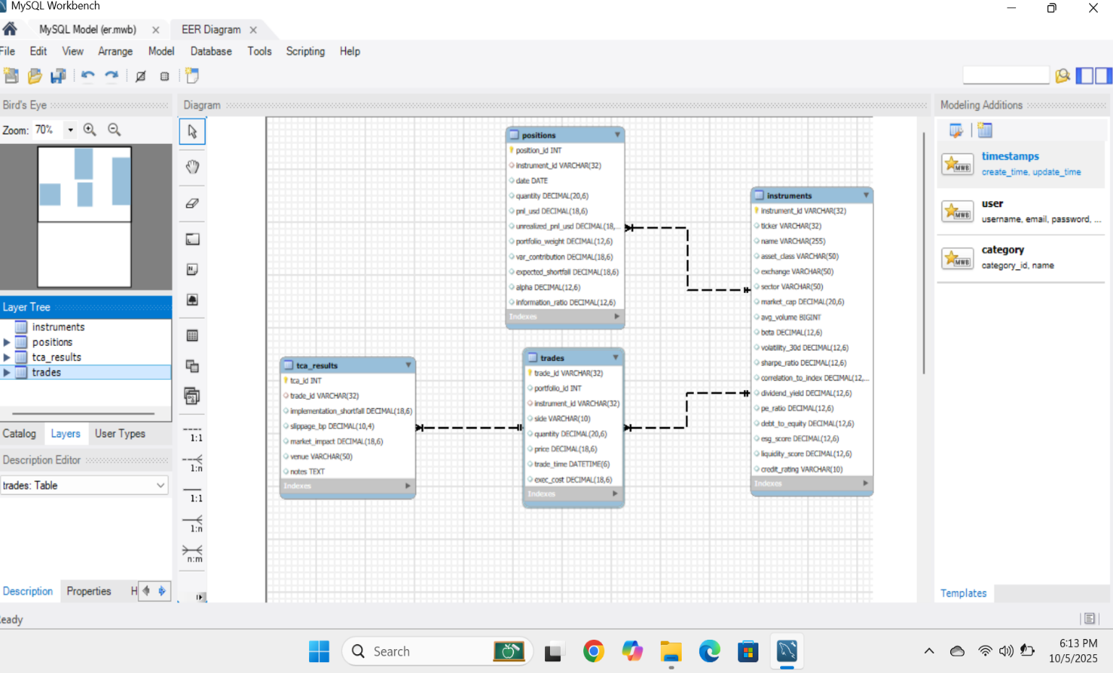
Figure 5.3.3: EER / Schema Design of RPAS Database.
5.3.4 Processing Layer (Core Analytical Modules)
This is the computational heart of the RPAS system. It contains four key analytical modules: Risk Analytics, Backtesting, Portfolio Optimization, and Transaction Cost Analysis (TCA). Each module performs specific calculations and analytics while sharing data from the common database.
- The Risk Analytics Module compute’s Value at Risk (VaR), Expected Shortfall (ES), and performs stress testing to measure portfolio exposure under different market scenarios.
- The Backtesting Module assesses historical strategy performance using actual market data.
- The Portfolio Optimization Module generates optimal asset allocations based on Modern Portfolio Theory, minimizing risk while maximizing returns.
- The Transaction Cost Analysis Module measures trading efficiency by calculating slippage, market impact, and commission costs.
All analytical outputs are consistent, validated, and traceable for audit purposes.
5.3.5 Reporting and Dashboard Layer
The Reporting Layer delivers all analytical outputs in user-friendly formats such as Excel reports, PDF summaries, and interactive dashboards. These dashboards display real-time insights on risk, performance, and trading costs. The system also supports role-based access control, ensuring that different stakeholders (e.g., analysts, portfolio managers, or compliance officers) receive relevant information according to their responsibilities. Reports are automatically generated at the end of each analytical cycle and stored in the database for future reference.
5.4 Explanation of the Diagram
The overall system architecture demonstrates a streamlined workflow where raw market data and trade logs are first collected from external sources and passed through the ingestion and validation layer. The validated data is stored in the central database, which serves as the backbone for all analytical modules. The processing layer then performs risk evaluation, portfolio optimization, backtesting, and transaction cost analysis based on the stored data. Finally, the processed outputs are compiled into analytical reports and dashboards within the reporting layer.
Data Ingestion & Validation

Database & Storage

External Data Source

Transaction Cost Analysis

Portfolio Optimization

Risk Analytics

Backtesting

Reporting & Dashboards

Figure 5.4.1: System Architecture of RPAS System.
This architecture ensures modularity, meaning that each layer can operate independently without affecting others. It also provides scalability for handling larger datasets or incorporating additional analytical modules in the future.
5.5 Daily Risk Job Workflow
The Daily Risk Job Workflow is an automated process within the RPAS system designed to provide portfolio managers, risk managers, and compliance officers with accurate, complete, and timely risk reports every morning before the market opens. By automating the process, it reduces manual effort, ensures data integrity, and produces audit-ready outputs for better decision-making.
Workflow Steps
5.5.1. Start / Scheduler Triggers Job
The workflow begins automatically via a scheduler at a predefined time, ensuring reports are ready before trading begins. Manual execution is also supported for ad-hoc analysis.
5.5.2. Load Market Data & Portfolios
Daily market data, including asset prices, interest rates, and volatilities, along with current portfolio holdings, are imported. This provides the most up-to-date information for all calculations.
5.5.3. Validate Data
The system performs checks for missing, incorrect, or inconsistent data. Any anomalies are flagged for review, ensuring only high-quality data enters the analysis.
5.5.4. Compute VaR & ES (95% & 99%)
Value at Risk (VaR) and Expected Shortfall (ES) are computed for each portfolio. These metrics measure potential losses under normal market conditions (VaR) and extreme scenarios (ES), using historical simulation, parametric approaches, or Monte Carlo methods.
5.5.5. Calculate Factor Exposures
The workflow evaluates sector, industry, or asset-class contributions to overall portfolio risk, helping managers understand key risk drivers and diversification levels.
5.5.6. Run Stress Tests
Predefined stress scenarios, such as market crashes, interest rate changes, or volatility spikes, are applied to assess portfolio resilience under extreme conditions.
5.5.7. Generate Alerts & Reports
Automatic alerts are sent if any risk thresholds are breached. Comprehensive reports summarizing VaR, ES, factor exposures, and stress test outcomes are generated in Excel, PDF, and dashboard formats, with all outputs logged for audit purposes.
Start / Scheduler triggers job

Load Market Data & Portfolios

Validate Data

Compute VaR & ES

Calculate Factor Exposures

Run Stress Tests

Generate Alerts & Reports

Figure 5.5.1: Data Risk Job Workflow

5.6 Technology Stack
The RPAS system is developed using a combination of robust and scalable technologies. Data ingestion and preprocessing are performed using Python, leveraging libraries such as NumPy and Pandas. Power Query is used for data transformation, while MySQL Workbench handles database design and management. The core analytical modules utilize Python’s SciPy and scikit-learn for optimization and computation. Reporting and visualization are implemented through Matplotlib, Excel, and automated PDF generation. Security is ensured through role-based access control and audit logging mechanisms, safeguarding all sensitive financial data.
Layer | Technologies Used
Data Sources | Market Feeds, Excel, CSV, API Integrations
Data Ingestion | Python (Pandas, NumPy), Power Query
Database | MySQL Workbench
Processing | Python (NumPy, Pandas, scikit-learn)
Reporting | Excel, Matplotlib, PDF Reports, Dashboards
Security | Role-based Access, Data Encryption, Audit Logs

5.7 Key Features of the Architecture
The RPAS architecture is characterized by several defining features that enhance its functionality and performance. Its automation capability eliminates manual workflows, enabling faster execution and reduced error rates. The auditability feature ensures that every computation, report, and dataset can be traced back to its source, supporting compliance with regulatory standards. The modular and scalable design allows easy upgrades or additions without disrupting existing functionality. Additionally, the system ensures high data security, processing efficiency, and accurate analytics, making it suitable for large-scale financial operations.
5.8 Advantages of the System Architecture
The architecture provides multiple strategic and operational advantages. It delivers timely and accurate insights into portfolio risk, performance, and transaction costs. The automated workflows reduce human dependency and enhance analytical precision. Centralized data management ensures transparency and traceability across all modules, while built-in scalability supports the integration of new data sources and analytical models in the future. Furthermore, the system’s modularity and audit readiness make it well-suited for financial institutions that require dependable, reproducible, and regulatory-compliant analytical frameworks.

5.9 Analytical Reports and Outputs
The outputs of the RPAS system validate its efficiency and analytical capability across multiple modules.
5.9.1. Portfolio Optimization Report
The Portfolio Optimization Module constructs efficient portfolios by balancing risk and return using Modern Portfolio Theory (MPT). It identifies the Minimum Variance Portfolio (MVP) and Maximum Sharpe Ratio Portfolio (MSP), providing optimal asset allocations based on historical data. Results are presented through allocation charts, efficient frontier plots, and summarized performance tables. These outputs help investors and portfolio managers in achieving optimal diversification and maximizing returns relative to risk.
5.9.2.Risk Analytics Report
The Risk Analytics Module calculates key performance metrics such as Value at Risk (VaR), Expected Shortfall (ES), and Drawdown Analysis. It also conducts stress testing to simulate extreme market events. Outputs include visual reports displaying portfolio exposure, risk distribution, and loss probability curves. This module provides critical insights into market vulnerabilities and helps organizations manage financial exposure proactively.
5.9.3.Backtesting Report
The Backtesting Module evaluates historical trading strategies like Buy & Hold, Momentum, and Mean Reversion. It measures their performance using cumulative returns and Sharpe ratios while incorporating realistic transaction costs. Findings indicate that Mean Reversion strategies performed better in the analyzed period. This module validates strategy robustness and assists in refining trading models.
5.9.4. Transaction Cost Analysis (TCA) Report
The Transaction Cost Analysis Module examines the efficiency of trading executions. It quantifies slippage, market impact, commissions, and total costs associated with trades. The module integrates these metrics into summarized reports and charts that help assess execution quality and cost-effectiveness across different sectors and strategies.
5.10 Summary
The Risk, Portfolio Optimization, Analytics, and Simulation (RPAS) system architecture offers a unified, automated, and modular analytical environment that integrates data collection, processing, analysis, and reporting. It is designed to meet the needs of modern financial institutions by ensuring accuracy, scalability, and security across all stages of the analytical process.
The system combines multiple analytical modules — Risk Analytics, Backtesting, Portfolio Optimization, and Transaction Cost Analysis (TCA) — within a single cohesive framework. Each module performs distinct analytical functions while remaining fully interoperable, ensuring smooth data flow and consistent performance. The modular design allows easy maintenance and scalability as new analytical capabilities or data sources are introduced.
Automation plays a key role in the RPAS workflow. Processes such as the Daily Risk Job automatically fetch and validate data, calculate risk metrics like Value at Risk (VaR) and Expected Shortfall (ES), and generate reports before the market opens. This reduces manual work, minimizes errors, and ensures decision-makers always have access to timely and accurate insights.
The system architecture also prioritizes data integrity, reliability, and security. All validated data, logs, and analytical outputs are securely stored in the database with audit trails, supporting compliance and governance standards. Using Python libraries like NumPy, Pandas, and Matplotlib, the system efficiently performs advanced analytics and generates clear visual reports for better decision-making.
In conclusion, the RPAS architecture delivers a robust and efficient analytical platform that enhances risk management, supports portfolio optimization, and promotes data-driven financial decisions. Its automation, modularity, and scalability make it a reliable solution for modern financial risk and portfolio analysis.

6. MODULE DESCRIPTION
The Financial Risk and Trading System (FRTS) is composed of multiple interconnected modules, each responsible for specific analytical and operational functions. These modules work together seamlessly to ensure efficient data handling, accurate computation, and timely reporting. The modular design enhances system flexibility, maintainability, and scalability, allowing each component to be developed, tested, and enhanced independently.
6.1 Data Ingestion and Validation Module
This module is responsible for importing raw data from multiple external sources such as market data feeds, portfolio holdings, and trade logs. It automatically validates all incoming data to ensure completeness, accuracy, and consistency. The process includes data cleansing, handling missing values, and standardizing formats before loading them into the database. By maintaining high data quality at the entry point, this module ensures that all subsequent analyses are reliable and error-free.
6.2 Database and Storage Module
The Database and Storage Module securely store’s all validated data, including historical records, portfolio details, trade transactions, and analytical results. It maintains data integrity, version control, and efficient retrieval for analytical processing. The database schema supports scalability through well-structured tables such as Instruments, Trades, Positions, and Risk-Metrics. It also performs regular backup and recovery operations, ensuring business continuity and data availability under all conditions.
6.3 Risk Analytics Module
The Risk Analytics Module serves as the analytical core of the FRTS system. It calculates essential risk measures including Value at Risk (VaR), Expected Shortfall (ES), Beta, and Volatility across portfolios and timeframes. Additionally, it performs stress testing and scenario analysis to evaluate portfolio performance under different market conditions. These analytical capabilities help risk managers identify exposures, anticipate losses, and ensure regulatory compliance.
6.4 Backtesting Module
The Backtesting Module assesses the accuracy and robustness of trading and risk models by comparing predicted results with actual market outcomes. It computes key performance indicators such as hit ratio, prediction accuracy, and model deviation, helping analysts evaluate model performance and refine strategies. This module ensures that all analytical models remain well-calibrated and aligned with real-world market dynamics.

6.5 Portfolio Optimization Module
This module is responsible for constructing and optimizing investment portfolios based on predefined objectives, such as maximizing returns, minimizing risk, or achieving specific risk-return ratios. It employs techniques like mean-variance optimization and Sharpe ratio maximization to dynamically adjust asset weights. Through these analytical methods, investors can identify optimal asset allocations that align with their financial goals and risk preferences.
6.6 Transaction Cost Analysis (TCA) Module
The Transaction Cost Analysis (TCA) Module evaluates the implicit and explicit costs associated with executing trades, including brokerage fees, bid-ask spreads, and market slippage. It compares executed trade prices against benchmark prices to assess execution quality. The insights derived from this module help traders and compliance teams minimize trading inefficiencies, reduce transaction costs, and enhance execution performance.
6.7 Reporting and Dashboard Module
The Reporting and Dashboard Module transforms analytical results into interactive dashboards and automated reports for stakeholders. It presents risk, performance, and transaction summaries in multiple formats — including Excel, PDF, and HTML — featuring tables, charts, and graphical insights. This module enables portfolio managers, analysts, and compliance officers to monitor portfolio health, risk exposure, and trading efficiency in real time.
6.8 Scheduler and Automation Module
This module automates recurring analytical workflows such as daily risk computation, data updates, and report generation. The built-in scheduler triggers predefined jobs (e.g., the Daily Risk Job) at fixed intervals, ensuring data consistency and eliminating manual errors. Through automation, the FRTS system achieves operational efficiency, faster turnaround times, and higher analytical accuracy.
6.9 Security and Access Control Module
The Security and Access Control Module ensure’s data protection, privacy, and controlled accessibility across the system. It manages user authentication, role-based authorization, and activity logging. Sensitive financial data is encrypted during both storage and transmission. Access permissions are defined based on user roles — such as Portfolio Manager, Risk Analyst, or Compliance Officer — to ensure adherence to organizational policies and regulatory requirements.

6.10 Integration and Communication Module
The Integration and Communication Module facilitate’s seamless interaction among various components of the FRTS system. It coordinates data exchange and process synchronization between analytical engines, the database, and the reporting layer. The module also supports API integrations and external system connectivity, allowing interoperability with enterprise reporting tools and external market data platforms.
6.11 Summary
Each module in the Financial Risk and Trading System performs a distinct yet complementary function, contributing to the system’s overall analytical strength. Together, they form a comprehensive, automated, and secure analytical ecosystem that supports real-time decision-making, enhances portfolio management, and strengthens risk oversight. The modular architecture ensures long-term adaptability to evolving financial regulations, analytical techniques, and technological advancements.

7. OUTPUT AND RESULTS
The Financial Risk and Trading System (RPAS) was developed to analyze financial market data, evaluate trading strategies, optimize portfolio allocations, and assess transaction costs within an integrated analytical environment. This section presents the outputs and results generated from the system’s core analytical modules — Risk Analytics, Backtesting, Portfolio Optimization, and Transaction Cost Analysis (TCA). Each module’s results are carefully evaluated in terms of accuracy, interpretability, and their contribution to decision-making.
7.1 Risk Analytics Module – Output Interpretation
The Risk Analytics Module focuses on measuring the stability, volatility, and performance consistency of trading strategies and portfolios. It evaluates the risk-adjusted performance through various time-series analyses and visual metrics. Key outputs include:
- Daily Profit and Loss (PnL): This chart highlights daily fluctuations in portfolio profit or loss, identifying volatility clusters and periods of high market activity.
- Rolling Sharpe Ratio (10-day & 30-day): It shows the moving risk-adjusted performance. A decline in the Sharpe Ratio indicates increased volatility or reduced returns.
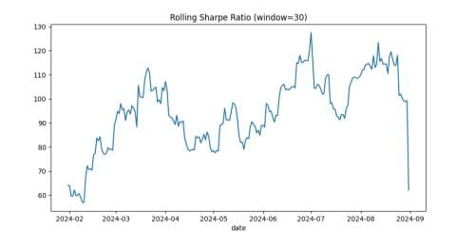
Figure 7.1.1 – Rolling Sharpe Ratio (Window = 30)

- Cumulative Returns Curve: This visual demonstrates the portfolio’s growth trend throughout the testing period, validating overall profitability and long-term capital appreciation.
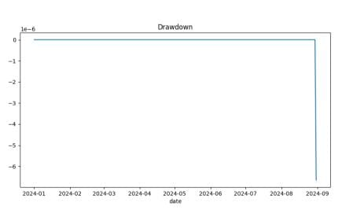
Figure 7.1.2 – Drawdown Chart
- Drawdown Analysis: It captures the extent and frequency of losses from the highest portfolio value, helping identify downside risk and recovery capability.
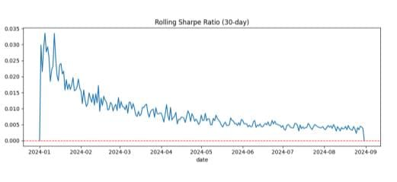
Figure 7.1.3 – Rolling Sharpe Ratio (30 Day)
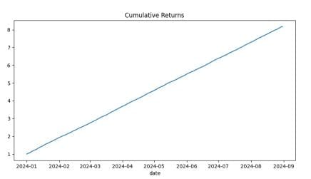
Figure 7.1.4 – Cumulative Returns Curve
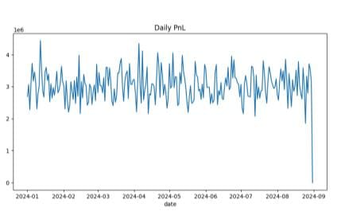
Figure 7.1.5 – Daily PnL (Profit and Loss) Line Chart
Overall, this module effectively visualizes the balance between risk and reward, confirming that the system can monitor portfolio exposure and detect performance degradation under different market conditions.

7.2 Backtesting Module – Strategy Validation
The Backtesting Module validates the robustness and profitability of multiple trading strategies by simulating them on historical market data. This ensures that the strategies perform consistently before being deployed in live trading.
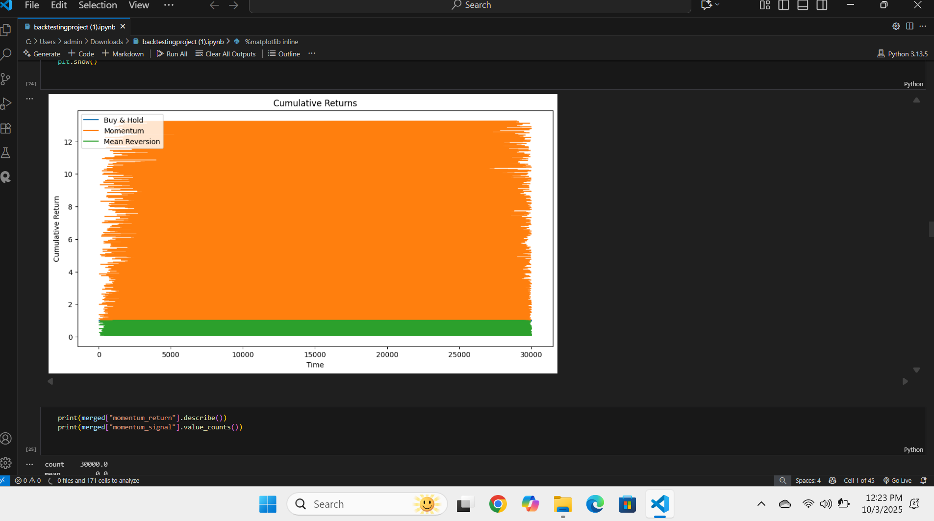
Figure 7.2.1 – Cumulative Returns Curve
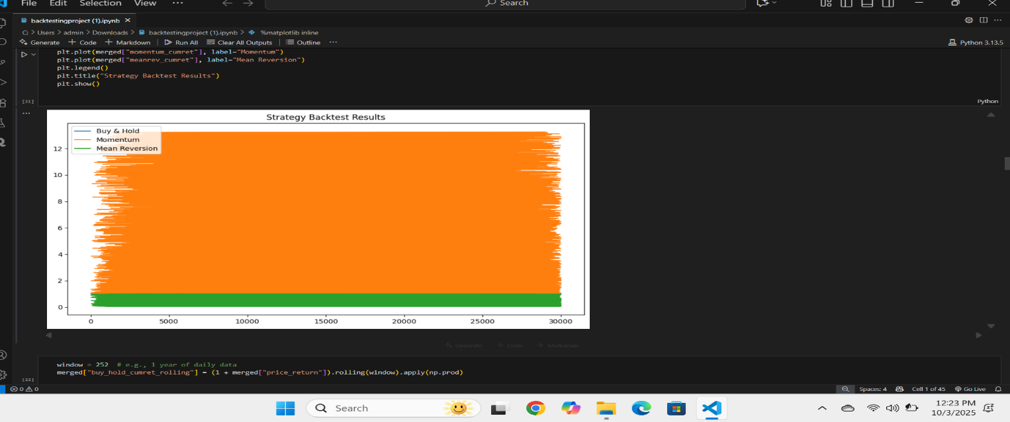
Figure 7.2.2 – Strategy Backtesting Results

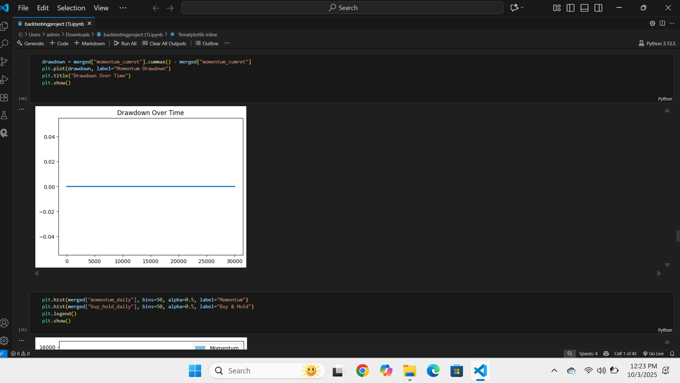
Figure 7.2.3 – Drawdown Over Time
Three trading strategies were evaluated:
- Buy & Hold Strategy: Represents a long-term, passive investment approach used as a performance benchmark.
- Momentum Strategy: Captures price trends by taking trades aligned with the direction of market movement.
- Mean Reversion Strategy: Identifies situations where prices deviate from and then revert to their historical averages
The primary outputs include Strategy Backtest Results, Cumulative Returns, and Drawdown Over Time. Analysis revealed that while the Buy & Hold strategy offered stable, steady returns, the Momentum and Mean Reversion strategies produced higher short-term profits with increased volatility. These results confirm that combining multiple strategies improves resilience and performance consistency in changing market environments.

7.3 Portfolio Optimization Module – Efficient Asset Allocation
The Portfolio Optimization Module is designed to identify the most efficient combination of financial assets that can maximize returns for a given level of risk, following the principles of Modern Portfolio Theory (MPT). This theory emphasizes diversification and the relationship between risk and return, helping investors make informed decisions based on quantitative analysis rather than intuition. The module integrates advanced numerical optimization techniques implemented through Python libraries such as NumPy, Pandas, and Matplotlib, allowing the system to process historical data, compute expected returns, and evaluate portfolio risk with precision.
In this module, the system constructs the Efficient Frontier, which is a graphical representation of optimal portfolios that offer the highest possible return for a specific amount of risk. Portfolios that lie below this curve are considered suboptimal because they provide lower returns for the same level of risk, while those on the curve are regarded as ideal and efficient. The Risk vs. Expected Return Plot further illustrates the relationship between portfolio volatility (standard deviation) and expected profit, enabling investors to visually assess the trade-off between potential reward and risk exposure.
The module also generates an Optimal Weight Distribution, which specifies how investment capital should be allocated across different assets. This allocation minimizes portfolio volatility while achieving desired return targets. By balancing high-risk and low-risk assets, the module ensures diversification — reducing the impact of poor performance from any single asset on the overall portfolio.
Through data-driven computation and visualization, this module empowers analysts and traders to make informed asset allocation decisions. It supports the development of risk-efficient, diversified investment strategies that can adapt to changing market conditions. The analysis also helps in understanding how portfolio performance can be optimized by adjusting weights based on risk tolerance, expected returns, and market volatility.
Additionally, the Portfolio Optimization Module enhances strategic financial planning and decision-making by providing clear, quantitative insights into how capital can be efficiently allocated. It allows investors to simulate multiple allocation scenarios, test various combinations of assets, and observe their effects on overall portfolio performance. This predictive capability helps in minimizing potential losses during adverse market conditions and maximizing opportunities when favorable trends emerge. By integrating optimization algorithms and real-world financial data, the module bridges the gap between theoretical investment models and practical portfolio management applications.
Overall, the Portfolio Optimization Module validates the system’s capability to intelligently construct and evaluate portfolios that achieve optimal performance under uncertain financial environments. By combining mathematical modeling, historical data, and computational techniques, it ensures an efficient, well-balanced, and strategically optimized investment portfolio suitable for both institutional and individual investors
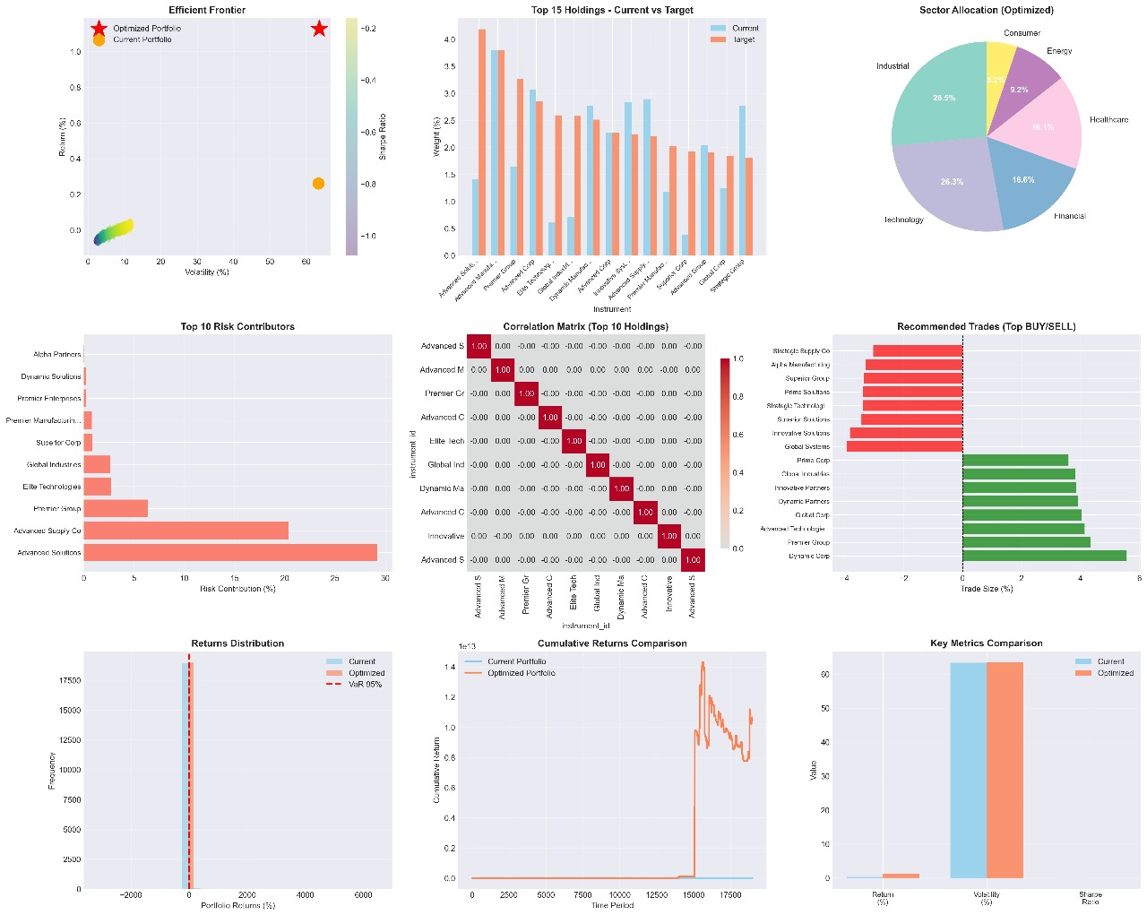
Figure 7.3.1 – Portfolio Optimization Outputs
7.4 Transaction Cost Analysis (TCA) Module – Execution Efficiency Evaluation
The Transaction Cost Analysis Module evaluates the cost-effectiveness and efficiency of trade executions by analyzing slippage, price impact, and transaction costs. It compares theoretical trade prices with actual execution prices to assess real-world trading efficiency.
Key outputs include:
- Execution Cost Distribution: Displays how transaction costs vary across trades.
- Price Impact Curve: Illustrates how large trade volumes influence market prices and execution efficiency.
- Implementation Shortfall Chart: Measures performance loss due to differences between ideal and actual execution.
- Volume vs. Cost Relationship: Shows how trade volume affects cost and liquidity.
The analysis revealed that transaction costs increase with larger trade sizes and higher market volatility. These insights help traders reduce slippage and optimize trading performance by adjusting trade size and timing.
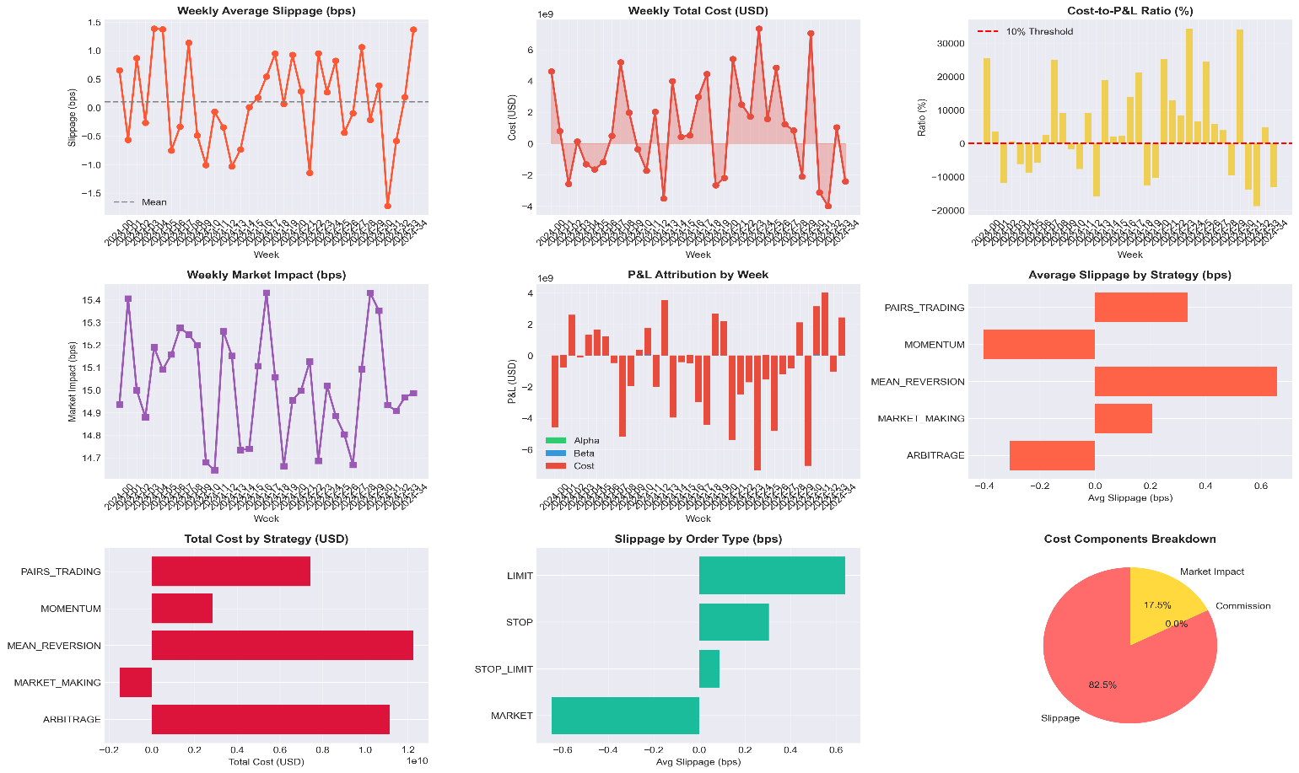
Figure 7.4.1 – TCA Outputs
7.5 Overall Performance Summary
The outputs from all four analytical modules demonstrate the comprehensive capabilities of the Financial Risk and Trading System (RPAS), highlighting its technical accuracy, operational efficiency, and strong analytical performance. Each module contributes uniquely to the system’s overarching goal of supporting data-driven investment decision-making.
Risk Analytics Module: This module effectively measures and quantifies market risk, analyzing volatility, stability, and consistency in returns across diverse financial instruments. By calculating key risk metrics such as Value at Risk (VaR), Conditional VaR, and volatility indexes, it provides investors with a clear understanding of potential downside exposure. Its precise modeling ensures that both short-term and long-term risk factors are accurately captured, supporting proactive risk management strategies.
Backtesting Module: The backtesting functionality validates the robustness and reliability of multiple trading strategies under historical market conditions. By simulating trades across various market scenarios, the module identifies which strategies consistently perform well and which are prone to underperformance. This iterative testing allows users to refine strategy parameters, assess strategy sensitivity to market changes, and gain confidence in deploying strategies in live trading environments.
Portfolio Optimization Module: Leveraging principles of Modern Portfolio Theory (MPT), this module identifies the most efficient asset combinations to achieve an optimal risk-return balance. By integrating advanced numerical techniques and historical data analysis, it provides recommendations for asset allocation that minimize risk while maximizing potential returns. Its optimization process accounts for correlation among assets, ensuring diversification benefits are fully utilized and reducing exposure to market shocks.
Transaction Cost Analysis (TCA) Module: The TCA module uncovers hidden costs associated with trade execution, including slippage, market impact, and fees. By analyzing trade-level data, it identifies inefficiencies in execution and suggests ways to reduce transaction costs. This enhances the overall cost-effectiveness of trading strategies and supports better decision-making in strategy selection and trade execution.
Integrated System Performance: Collectively, these modules form a cohesive analytical ecosystem. The RPAS system not only evaluates individual strategies and asset behaviors but also integrates findings to provide a holistic view of portfolio performance, risk exposure, and cost efficiency. Its multi-layered analytical framework empowers quantitative trading, strategic portfolio management, and financial research with actionable insights. Users benefit from a unified platform where risk, strategy, optimization, and execution are analyzed simultaneously, promoting informed, data-driven investment decisions.
Practical Applications: Beyond theoretical accuracy, the system demonstrates practical value in real-world scenarios, including managing institutional investment portfolios, developing automated trading strategies, conducting market research, and performing regulatory compliance reporting. Its modular and scalable architecture ensures that it can adapt to evolving market conditions and increasingly complex financial instruments, making RPAS a reliable tool for both professional investors and research analysts

8. TESTING AND VALIDATION
Testing and validation are essential to ensure that the RPAS (Risk, Backtesting, Portfolio Optimization, and TCA System) performs as intended and delivers accurate, reliable results. To achieve this, the system will undergo testing at multiple levels, including unit testing, integration testing, system testing, performance testing, and user acceptance testing (UAT). This structured approach ensures both the technical functionality and business requirements are fully validated.
8.1 Unit Testing
Unit testing focuses on verifying the functionality of individual components or modules in isolation. This includes testing functions such as risk calculation formulas (Value at Risk and Expected Shortfall), backtesting logic, optimization algorithms, and transaction cost analysis (TCA) calculations. The primary goal of unit testing is to ensure that each function produces correct results for a given set of inputs. Automated test cases will be developed to compare the actual outputs of each function with expected results. For example, the system will be tested to verify correct VaR calculation for a sample dataset, ensure optimization algorithms respect turnover limits, and confirm that transaction costs are properly deducted during backtests.
8.2 Integration Testing
Integration testing validates how different system modules interact and work together. The scope includes workflows such as data ingestion with the risk engine, backtesting with reporting modules, optimization with reporting, and TCA with execution data. The objective is to confirm that data flows correctly between modules and that end-to-end processes execute without errors. Integration tests will be conducted using sample datasets. Examples include loading market data to run a daily risk job and produce a risk report, defining a strategy to perform a backtest and generate a performance report, or optimizing a portfolio to produce trade recommendations and generate an optimization report.
8.3 System Testing
System testing evaluates the complete RPAS as a whole to ensure all components function correctly in combination. This level of testing covers all system functionalities, including risk analytics, backtesting optimization, TCA, and reporting. The main objective is to verify that the system meets the specifications defined in the SRS and satisfies user requirements. System test scenarios will simulate actual usage by risk managers, portfolio managers, quants, and auditors, ensuring the system behaves as intended in real-world conditions.

8.4 Performance Testing
Performance testing is conducted to ensure that the system meets its response time, scalability, and reliability requirements. The scope includes daily jobs, handling large portfolios, and generating reports efficiently. The goal is to verify that the system can process large datasets and complete daily operations within acceptable time limits. Stress tests and load tests will be performed to measure system performance. Key performance criteria include completing daily jobs within 30 minutes of data arrival, supporting more than 10,000 positions without degradation, and ensuring 95% of user queries respond in under two seconds.8
8.5 User Acceptance Testing (UAT)
User Acceptance Testing ensures that the system fulfills business requirements and meets end-user expectations. The scope includes final validation of system outputs by risk managers, portfolio managers, quants, and auditors. The goal is to confirm that the reports are accurate, user-friendly, and audit-ready. During UAT, users will test system features using sample portfolios and verify that outputs align with expectations. Acceptance criteria include correct display of risk metrics (VaR, ES, and exposures), realistic and reproducible backtesting results, valid trade recommendations from portfolio optimization, and accurate cost attribution in TCA reports.
8.6 Validation Approach
Validation ensures that the system not only functions correctly but also provide’s value to users. This involves multiple layers: data validation, where input data is checked for completeness and accuracy; process validation, where calculations and workflows are verified against benchmarks; output validation, where reports are reviewed by domain experts; and audit validation, ensuring each run is reproducible with saved configurations, data snapshots, and code versions. Together, these measures confirm that the RPAS operates reliably and produces trustworthy results.

9. DEPLOYMENT AND MAINTENANCE
Deployment and maintenance are critical to ensure that the RPAS (Risk, Backtesting, Portfolio Optimization, and TCA System) operates smoothly in production and continues to meet user needs over the long term. This section explains how the system will be deployed, secured, monitored, and maintained.
9.1 Deployment Approach
The system will be deployed using a modular and scalable architecture to provide both flexibility and reliability. It will be hosted either on secure servers or in a cloud environment, depending on organizational requirements. To improve scalability and efficiency, the system’s components such as databases, compute engines, and dashboards will be deployed as independent modules.
The deployment process will follow several steps. Initially, the infrastructure, including servers, databases, and storage, will be configured. Once infrastructure is ready, application modules covering risk analytics, backtesting, optimization, TCA, and reporting will be installed. After installation, the system will be integrated with external data sources such as market data feeds, trade logs, and portfolio systems. Deployment verification tests will then be conducted to confirm that all modules function correctly together. Finally, the system will be moved into production, where it will be made available to portfolio managers, risk teams, quants, and auditors.
Depending on the needs of the organization, the system may be deployed fully on-premises, entirely cloud-based, or in a hybrid model. This flexibility ensures compatibility with different IT strategies and compliance requirements.
9.2 Security Measures
Given that the system handles sensitive financial and trading data, security is one of the most important aspects of deployment. All data will be encrypted both at rest and during transmission to prevent unauthorized access. Database access will be restricted to authorized personnel only, ensuring that only trusted users can interact with core data.
Role-based access control will be implemented, meaning that each type of user—such as Risk Managers, Portfolio Managers, Quants, and Auditors—will only be able to access features relevant to their responsibilities. To strengthen authentication, multi-factor authentication (MFA) will be used for all user logins. In addition, the system will maintain audit logs, recording every user activity such as logins, report downloads, and data access. These logs will be essential for compliance, audits, and internal investigations.

9.3 Monitoring and Maintenance
To ensure continuous and reliable operation, the system will be equipped with robust monitoring and maintenance processes. Automated monitoring tools will track the health of the system, job completion times, and potential failures. If a scheduled daily task, such as a risk calculation or report generation, fails to execute properly, the system will immediately trigger alerts to notify administrators.
In addition to system monitoring, data monitoring will be performed daily. Input data will be checked for completeness, accuracy, and consistency. Any missing values or errors will generate alerts for review before calculations are executed. Maintenance activities will be part of ongoing operations and will include regular updates to data pipelines, database systems, and reporting tools. Identified bugs will be addressed promptly, while system upgrades will be scheduled periodically to improve performance or add new features. All upgrades will take place outside of trading hours to prevent interruptions.
9.4 Backup and Recovery
A comprehensive backup and recovery plan will be implemented to prevent data loss and ensure business continuity. Daily backups of databases, reports, and audit logs will be maintained, and weekly full backups will be stored securely in offsite or cloud-based locations.
In the event of a system or hardware failure, a disaster recovery plan will be activated. This plan ensures that the system can be restored quickly to full functionality. Recovery Time Objectives (RTO) will be established, defining how fast the system should be restored to avoid impacting business operations. With these measures in place, users can be confident that critical data and reports are safe, even in the case of unexpected disruptions.
9.5 Maintenance Plan
The long-term sustainability of the system depends on a structured maintenance plan. Scheduled downtimes will be arranged during non-trading hours to perform upgrades, apply patches, or carry out system maintenance without interrupting daily operations.
To support users, a dedicated helpdesk will be available for addressing queries, troubleshooting issues, and providing technical assistance. Alongside this, user manuals and technical documentation will be updated regularly, particularly whenever new system releases are rolled out.
Finally, continuous improvement will be encouraged by collecting feedback from end-users such as portfolio managers, risk teams, and auditors. This feedback will guide future system enhancements, ensuring that the RPAS continues to evolve and remain relevant to the needs of its users.

10. FUTURE ENHANCEMENTS
Although the RPAS (Risk, Backtesting, Portfolio Optimization, and TCA System) has been designed to meet current business needs, there are several opportunities for future enhancements. These enhancements will make the system more advanced, user-friendly, and adaptable to changing financial markets and organizational requirements.
10.1 Real-Time Intraday Risk Monitoring
Currently, the system runs risk analytics as daily jobs. In the future, the system could be upgraded to perform real-time or intraday risk monitoring. This enhancement would allow risk managers and portfolio managers to see how their portfolios are performing and how risks are evolving during the trading day. By having access to real-time insights, users could make faster and more informed decisions, especially in volatile markets.
10.2 Support for Additional Asset Classes
The present system mainly focuses on equities and standard portfolios. Future versions can expand support to cover additional asset classes such as fixed income, derivatives, commodities, and cryptocurrencies. Including more asset types will make the system more versatile, allowing organizations to manage risks and optimize portfolios across a wider range of investments.
10.3 Artificial Intelligence and Machine Learning
Future enhancements can integrate AI and machine learning techniques to improve the accuracy and efficiency of different modules. For example, predictive models could forecast transaction costs more accurately in the TCA module, or machine learning models could identify patterns in historical data to suggest new strategies during backtesting. These technologies would give the system more intelligence and adaptability.
10.4 Advanced Visualization and Dashboards
At present, the system generates detailed PDF and Excel reports along with dashboards. Future improvements could include more interactive dashboards with advanced visualization tools, real-time data streaming, and customizable user views. This would allow users to interact with data more effectively and tailor reports or dashboards to their specific needs.
10.5 Collaboration Features and Role Management
Future versions of the system could include advanced collaboration tools that allow multiple users to work together more efficiently. Features such as shared dashboards, version-controlled reports, and workflow tracking would help large teams coordinate their work. Improved role management could also provide more granular control over permissions, ensuring data security while supporting teamwork.
10.6 Integration with External Systems
The system can be further enhanced by integrating with external trading platforms, portfolio management tools, and compliance systems. Although the current system does not perform live trading, future versions could provide seamless integration with broker platforms for trade execution recommendations or compliance checks.
10.7 Cloud-Native and Scalable Architecture
While the current system supports both on-premises and cloud deployment, future versions could be designed as fully cloud-native applications. This would allow organizations to scale resources dynamically based on workload, reduce infrastructure costs, and improve system performance during peak usage.
10.8 Enhanced Audit and Compliance Tools
Another area of future improvement is the audit and compliance module. Enhancements could include automated compliance checks, AI-driven anomaly detection, and more detailed regulatory reporting features. These improvements would help organizations stay compliant with changing regulatory requirements and industry standards.

11. APPENDICES
The appendices provide additional supporting information that complements the main sections of this Software Requirements Specification (SRS). These materials include technical formulas, definitions of terms, sample report layouts, and other details to help readers understand the system’s functions and outputs more effectively.
11.1 Risk Calculation Formulas
The system utilizes well-established financial formulas to calculate key risk measures within the Risk Analytics Module. These formulas ensure consistent and reliable reporting.

Measure | Definition | Purpose / Use | Example
Value at Risk (VaR) | Maximum potential loss of a portfolio over a given time horizon at a specified confidence level | Quantifies the worst expected loss under normal market conditions | 95% one-day VaR: max loss expected in one day with 95% confidence
Expected Shortfall (ES) / Conditional VaR | Average loss expected if losses exceed the VaR threshold | Measures tail risk for extreme market conditions | If VaR = $1M, ES might show $1.2M average loss in worst-case scenarios

11.2 Stress Testing Scenarios
Stress testing simulates extreme market conditions to evaluate portfolio resilience. The system supports both predefined and customizable stress scenarios.
Scenario | Description / Impact | Purpose
Interest Rate Shock | Sudden increase in interest rates | Tests portfolio sensitivity to rate changes
Sector Crash | Specific sector loses 30% value | Evaluates sector exposure risk
Volatility Spike | Doubling of market volatility | Assesses portfolio stability under extreme fluctuations

11.3 Sample Report Layouts
Reports are the central outputs of the RPAS system. Each report contains key data, insights, and metadata for auditability. Below are the standard report types and their typical contents:
Report Type | Key Contents | Metadata Included
Risk Report | Daily VaR, Expected Shortfall, Factor exposures, Stress test results | Date, Code version, Data snapshot
Performance Report | Returns, Sharpe ratio, Volatility, Maximum drawdown | Date, Code version, Data snapshot
TCA Report | Trading costs (slippage, commissions), Market impact, Cost attribution | Date, Code version, Data snapshot
Optimization Report | Recommended trades, Expected risk-return outcomes, Portfolio allocations | Date, Code version, Data snapshot

11.4 Glossary of Key Terms
This section defines important financial and technical terms to make the SRS accessible to both technical and non-technical users.
Term | Definition / Explanation
Alpha
  Returns generated due to manager skill rather than market movement.
Beta | Returns due to overall market exposure.
Sharpe Ratio
  Measure of risk-adjusted return.
Slippage | Difference between expected and actual trade execution price.
Market Impact | Effect of a trade on the market price of a security.
Turnover | Percentage of a portfolio traded or changed in a given period.
Reproducibility | Ability to repeat an analysis/backtest with identical inputs and get the same results
11.5 References and Standards
The RPAS system design follows established industry practices, regulatory standards, and academic research in the areas of:
Category | Description / Sources
Industry Practices | Portfolio management frameworks, risk management practices
Regulatory Requirements | Guidelines and compliance standards for financial risk reporting
Academic Research | Published studies on portfolio optimization, risk analytics, and transaction cost analysis

